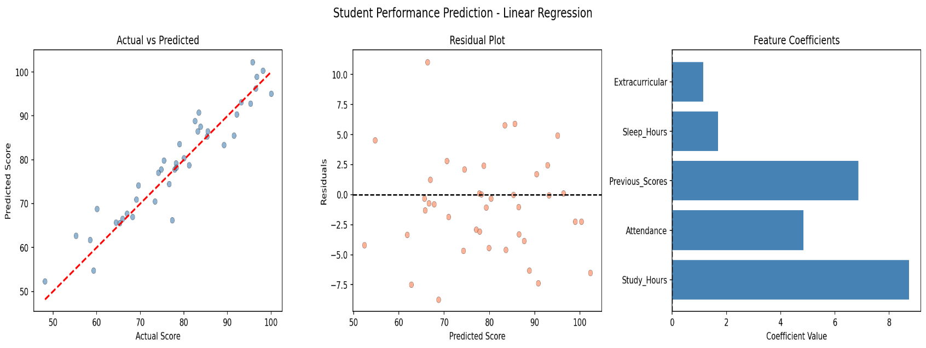 =======================================================
STUDENT PERFORMANCE PREDICTION - Linear Regression
=======================================================
── Dataset Overview ──
Study_Hours Attendance Previous_Scores Sleep_Hours Extracurricular Final_Score
count 200.00 200.00 200.00 200.00 200.00 200.00
mean 5.36 75.22 71.24 6.39 0.46 78.69
std 2.65 14.65 18.44 1.39 0.50 12.52
min 1.05 50.25 40.65 4.09 0.00 48.15
25% 3.06 63.07 55.33 5.18 0.00 69.36
50% 5.45 77.08 71.52 6.34 0.00 78.75
75% 7.81 87.11 88.67 7.62 1.00 87.70
max 9.88 99.53 99.98 8.95 1.00 100.00

── Model Evaluation Metrics ─ ── Feature Coefficients ──
Mean Absolute Error (MAE) : 3.1935 Study_Hours : 8.7322
Mean Squared Error (MSE) : 17.1299 Attendance : 4.8383
Root MSE (RMSE) : 4.1388 Previous_Scores : 6.8666
R² Score : 0.8952 Sleep_Hours : 1.6923
Extracurricular : 1.1380
Intercept : 78.8055

